**Chapter 2: PORTFOLIO THEORY**

1. You invest $27,000 in a corporate bond selling for $900 per $1,000 par value. Over the coming year, the bond will pay interest of $75 per $1,000 of par value. The price of the bond at the end of the year will depend on the  
   level of interest rates prevailing at that time. You construct the following scenario analysis:

|  |  |  |
| --- | --- | --- |
| **Interest Rates** | **Probability** | **Year-End Bond Price** |
| Higher | 0.2 | $850 |
| Unchanged | 0.5 | 915 |
| Lower | 0.3 | 985 |

Your alternative investment is a T-bill that yields a sure rate of return of 5%. Calculate the HPR for each scenario, the expected rate of return, and the risk premium on your investment. What is the expected end-of-year dollar  
value of your investment?

1. You invest $1 million at the beginning of 2020 in an S&P 500 stock-index fund. If the rate of return in 2020 is -40%, what rate of return in 2021 will be necessary for your portfolio to recover to its original value?
2. Suppose your expectations regarding the stock price are as follows:

|  |  |  |  |
| --- | --- | --- | --- |
| **State of the Market** | **Probability** | **Ending Price** | **HPR (including dividends)** |
| Boom | 0.35 | $140 | 44.5% |
| Normal growth | 0.30 | 110 | 14.0 |
| Recession | 0.35 | 80 | -16.5 |

Compute the mean and standard deviation of the HPR on stocks.

1. You are faced with the probability distribution of the HPR on the stock market index fund as follows:

Purchase Price: $100/share

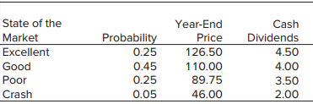

1. What is the expected rate of return on the index fund?
2. Suppose the price of a put option on a share of the index fund with exercise price of $110 and time to expiration of 1 year is $12. What is the probability distribution of the HPR on the put option?
3. What is the probability distribution of the HPR on a portfolio consisting of one share of the index fund and a put option?
4. In what sense does buying the put option constitute a purchase of insurance in this case?
5. (CFA Problem) Given $100,000 to invest, what is the expected risk premium in dollars of investing in equities versus risk-free T-bills (U.S. Treasury bills) based on the following table?

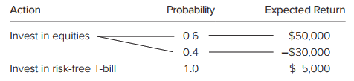

1. (CFA Problem) Based on the scenarios below, what is the expected return for a portfolio with the following return profile?

|  |  |  |  |
| --- | --- | --- | --- |
|  | **Bear Market** | **Normal Market** | **Bull Market** |
| *Probability* | 0.2 | 0.3 | 0.5 |
| *Rate of return* | -25% | 10% | 24% |

1. (CFA Problem) Use the following scenario analysis for Stocks X and Y to answer questions (round to the nearest percent).

|  |  |  |  |
| --- | --- | --- | --- |
|  | **Bear Market** | **Normal Market** | **Bull Market** |
| *Probability* | 0.2 | 0.5 | 0.3 |
| *Stock X* | -20% | 18% | 50% |
| *Stock Y* | -15% | 20% | 10% |

1. What are the expected rates of return for Stocks X and Y?
2. What are the standard deviations of returns on Stocks X and Y?
3. Assume that of your $10,000 portfolio, you invest $9,000 in Stock X and $1,000 in Stock Y. What is the expected return on your portfolio?
4. An analyst estimates that a stock has the following probabilities of return depending on the state of the economy:

|  |  |  |
| --- | --- | --- |
| *State of Economy* | **Probability** | **Return** |
| *Good* | 0.1 | 15% |
| *Normal* | 0.6 | 13 |
| *Poor* | 0.3 | 7 |

What is the expected return of the stock?

1. A portfolio has an expected rate of return of 20% and standard deviation of 30%. T-bills offer a safe rate of return of 7%. Would an investor with risk-aversion parameter A = 4 prefer to invest in T-bills or the risky portfolio? What if A = 2?
2. Can the Sharpe (reward-to-volatility) ratio, S = [E(rC) - rf]/σC, of any combination of the risky asset and the risk-free asset be different from the ratio for the risky asset taken alone, [E(rP) - rf]/σP?
3. Which of the following statements are true? Explain.
4. A lower allocation to the risky portfolio reduces the Sharpe (reward-to-volatility) ratio.
5. The higher the borrowing rate, the lower the Sharpe ratios of levered portfolios.
6. With a fixed risk-free rate, doubling the expected return and standard deviation of the risky portfolio will double the Sharpe ratio.
7. Holding constant the risk premium of the risky portfolio, a higher risk-free rate will increase the Sharpe ratio of investments with a positive allocation to the risky asset.
8. What do you think would happen to the portion of risky assets in complete portfolio if investors perceived higher volatility in the equity market?
9. Consider a portfolio that offers an expected rate of return of 12% and a standard deviation of 18%. T-bills offer a risk-free 7% rate of return. What is the maximum level of risk aversion for which the risky portfolio is still preferred to T-bills?

**Use these inputs for Exercises 14 through 19:** You manage a risky portfolio with an expected rate of return of 18% and a standard deviation of 28%. The T-bill rate is 8%.

1. Your client chooses to invest 70% of a portfolio in your fund and 30% in an essentially risk-free money market fund. What is the expected value and standard deviation of the rate of return on his portfolio?
2. Suppose that your risky portfolio includes the following investments in the given proportions:

|  |  |
| --- | --- |
| Stock A | 25% |
| Stock B | 32% |
| Stock C | 43% |

What are the investment proportions of your client’s overall portfolio, including the position in T-bills?

1. What is the reward-to-volatility (Sharpe) ratio (*S*) of your risky portfolio? Your client’s?
2. Draw the CAL of your portfolio on an expected return–standard deviation diagram. What is the slope of the CAL? Show the position of your client on your fund’s CAL.
3. Suppose that your client decides to invest in your portfolio a proportion *y* of the total investment budget so that the overall portfolio will have an expected rate of return of 16%.
4. What is the proportion *y*?
5. What are your client’s investment proportions in your three stocks and the T-bill fund?
6. What is the standard deviation of the rate of return on your client’s portfolio?
7. Your client’s degree of risk aversion is *A* = 3.5.
8. What proportion, *y,* of the total investment should be invested in your fund?
9. What is the expected value and standard deviation of the rate of return on your client’s optimized portfolio?

**Use the following data in answering Exercise 20 - 22:**

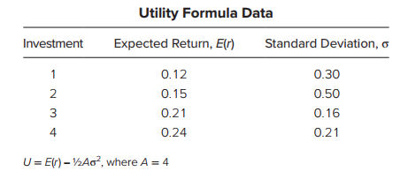

1. *(CFA Problem)* On the basis of the utility formula above, which investment would you select if you were risk averse with *A* = 4?
2. *(CFA Problem)* On the basis of the utility formula above, which investment would you select if you were risk neutral?
3. *(CFA Problem)* The variable (*A*) in the utility formula represents the:
4. Investor’s return requirement.
5. Investor’s aversion to risk.
6. Certainty equivalent rate of the portfolio.
7. Preference for one unit of return per four units of risk.
8. *(CFA Problem)* You manage an equity fund with an expected risk premium of 10% and an expected standard deviation of 14%. The rate on Treasury bills is 6%. Your client chooses to invest $60,000 of her portfolio in your equity fund and $40,000 in a T-bill money market fund.
9. What is the expected return and standard deviation of return on your client’s portfolio?
10. What is the reward-to-volatility (Sharpe) ratio for the *equity fund,* for your client’s portfolio?
11. *(IFM sample questions)* You are given the following information about an asset.
12. Using 36 years of data, the average annual asset return is 10%.
13. The volatility of the asset’s return, over the same time period, was estimated to be 27%.
14. The distributions of each year’s returns are identically distributed and independent from each other year’s returns.

Calculate the lower bound of the 95% confidence interval for the asset’s annual expected return, using the approximation formula given in *Corporate Finance*.

1. 1.0%
2. 2.6%
3. 4.5%
4. 5.5%
5. 8.5%
6. *(IFM sample questions)* You are given the following information about a portfolio with four assets.

|  |  |  |
| --- | --- | --- |
| Asset | Market Value of Asset | Covariance of asset’s return with the portfolio return |
| I | 40,000 | 0.15 |
| II | 20,000 | -0.10 |
| III | 10,000 | 0.20 |
| IV | 30,000 | -0.05 |

Calculate the standard deviation of the portfolio return.

1. 4.50%
2. 13.2%
3. 20.0%
4. 21.2%
5. 44.7%
6. *(IFM sample questions)* You are given the following information about the annual returns of two stocks, *X* and *Y*:
7. The expected returns of *X* and *Y* are E[*RX*] = 10% and E[*RY*] = 15%.
8. The volatilities of the returns are *VX* =18% and *VY* = 20%.
9. The correlation coefficient of the returns for these two stocks is 0.25.
10. The expected return for a certain portfolio, consisting only of stocks *X* and *Y*, is 12%.

Calculate the volatility of the portfolio return.

1. 10.88%
2. 12.56%
3. 13.55%
4. 14.96%
5. 16.91%
6. *(IFM sample questions)* You are given the following information about a portfolio consisting of stocks X, Y, and Z:

|  |  |  |
| --- | --- | --- |
| Stock | Investment | Expected Return |
| X | 10,000 | 8% |
| Y | 15,000 | 12% |
| Z | 25,000 | 16% |

Calculate the expected return of the portfolio.

1. 10.8%
2. 11.4%
3. 12.0%
4. 12.6%
5. 13.2%
6. *(IFM sample questions)* You are given the following information about a two-asset portfolio:
7. The Sharpe ratio of the portfolio is 0.3667.
8. The annual effective risk-free rate is 4%.
9. If the portfolio were 50% invested in a risk-free asset and 50% invested in a risky asset X, its expected return would be 9.50%.

Now, assume that the weights were revised so that the portfolio were 20% invested in a risk-free asset and 80% invested in risky asset X.

Calculate the standard deviation of the portfolio return with the revised weights.

1. 6.0%
2. 6.2%
3. 12.8%
4. 15.0%
5. 24.0%
6. *(IFM sample questions)* You are given the following information about an equally-weighted portfolio of *n* stocks:
7. For each individual stock in the portfolio, the variance is 0.20.
8. For each pair of distinct stocks in the portfolio, the covariance is 0.10.

Determine which graph displays the variance of the portfolio as a function of *n*.

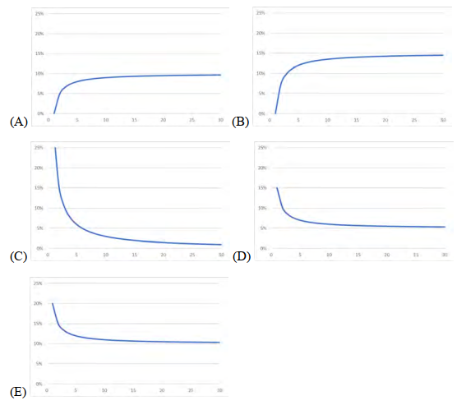

1. *(IFM sample questions)* You are given the following information about three stocks (X, Y, and Z) in a portfolio:
2. The covariance matrix for each stock with each other stock is given in the following table:

|  |  |  |  |
| --- | --- | --- | --- |
|  | X | Y | Z |
| X | 0.040 | -0.018 | 0.016 |
| Y | -0.018 | 0.090 | -0.021 |
| Z | 0.016 | -0.021 | 0.010 |

1. The weighting of each stock in the portfolio is as follows:

|  |  |
| --- | --- |
| Stock | Weighting |
| X | 30% |
| Y | 20% |
| Z | 50% |

Calculate the variance of this portfolio.

1. 0.0081
2. 0.0089
3. 0.0123
4. 0.0902
5. 0.0944
6. *(IFM sample questions)* You are given the following information about a portfolio that has two equally-weighted stocks, X and Y.
7. The economy over the next year could be good or bad with equal probability.
8. The returns of the stocks can vary as shown in the table below:

|  |  |  |
| --- | --- | --- |
| Stock | Return when economy is good | Return when economy is bad |
| X | 10% | –2% |
| Y | 18% | –5% |

Calculate the volatility of the portfolio return.

1. 1.80%
2. 6.90%
3. 7.66%
4. 8.75%
5. 13.42%
6. When adding real estate to an asset allocation program that currently includes only stocks, bonds, and cash, which of the properties of real estate returns affect portfolio risk? Explain.
7. Standard deviation.
8. Expected return.
9. Correlation with returns of the other asset classes.
10. The universe of available securities includes two risky stock funds, A and B, and T-bills. The data for the universe are as follows:

|  |  |  |
| --- | --- | --- |
|  | **Expected Return** | **Standard Deviation** |
| **A** | 10% | 20% |
| **B** | 30 | 60 |
| **T-bills** | 5 | 0 |

The correlation coefficient between funds A and B is -0.2.

1. Draw the opportunity set of funds A and B.
2. Find the optimal risky portfolio, P, and its expected return and standard deviation.
3. Find the slope of the CAL supported by T-bills and portfolio P.
4. How much will an investor with A = 5 invest in funds A and B and in T-bills?

|  |  |  |  |
| --- | --- | --- | --- |
| wA | wB | E (r ) | σ |
| 0.0 | 1.0 |  |  |
| 0.1 | 0.9 |  |  |
| 0.2 | 0.8 |  |  |
| 0.3 | 0.7 |  |  |
| 0.4 | 0.6 |  |  |
| 0.5 | 0.5 |  |  |
| 0.6 | 0.4 |  |  |
| 0.7 | 0.3 |  |  |
| 0.8 | 0.2 |  |  |
| 0.9 | 0.1 |  |  |
| 1.0 | 0.0 |  |  |

* Draw the graph.

**The following data apply to Exercises 34 through 40:** A pension fund manager is considering three mutual funds. The first is a stock fund, the second is a long-term government and corporate bond fund, and the third is a T-bill money market fund that yields a rate of 8%. The probability distribution of the risky funds is as follows:

|  |  |  |
| --- | --- | --- |
|  | **Expected Return** | **Standard Deviation** |
| **Stock fund (*S*)** | 20% | 30% |
| **Bond fund (*B*)** | 12 | 15 |

The correlation between the fund returns is 0.10.

1. What are the investment proportions in the minimum-variance portfolio of the two risky funds, and what is the expected value and standard deviation of its rate of return?
2. Tabulate and draw the investment opportunity set of the two risky funds. Use investment proportions for the stock fund of 0% to 100% in increments of 20%.
3. Draw a tangent from the risk-free rate to the opportunity set. What does your graph show for the expected return and standard deviation of the optimal portfolio?
4. Solve numerically for the proportions of each asset and for the expected return and standard deviation of the optimal risky portfolio.
5. What is the Sharpe ratio of the best feasible CAL?
6. You require that your portfolio yield an expected return of 14%, and that it be efficient, on the best feasible CAL.
7. What is the standard deviation of your portfolio?
8. What is the proportion invested in the T-bill fund and each of the two risky funds?
9. If you were to use only the two risky funds, and still require an expected return of 14%, what would be the investment proportions of your portfolio? Compare its standard deviation to that of the optimized portfolio in Exercise 39. What do you conclude?
10. *(IFM Study Manual)* For a stock, you are given the following prices and dividends:

|  |  |  |
| --- | --- | --- |
| Date | Price | Dividend |
| 12/31/18 | 25.46 | 1.00 |
| 3/31/19 | 24.22 | 1.00 |
| 6/30/19 | 25.52 | 1.00 |
| 9/30/19 | 25.88 | 1.00 |
| 12/30/19 | 26.11 | 1.00 |

Calculate the realized return on the stock for 2019.

1. *(IFM Study Manual)* For a stock, you are given the following realized returns:

|  |  |
| --- | --- |
| Year | Return |
| 2014 | 0.2642 |
| 2015 | 0.0110 |
| 2016 | 0.1562 |
| 2017 | -0.1734 |
| 2018 | 0.0247 |

The expected return is calculated as the average of the returns for 2014 – 2018.

Calculate the standard error of the estimate of expected return.

1. *(IFM Study Manual)* You are given the following realized returns for two stocks, DAB and FCE:

|  |  |  |
| --- | --- | --- |
| Year | DAB | FCE |
| 2015 | 0.1245 | 0.0644 |
| 2016 | 0.3042 | 0.1212 |
| 2017 | -0.2577 | -0.0244 |
| 2018 | 0.0102 | 0.0840 |

Calculate the covariance of the returns.

1. *(IFM Study Manual)* You are considering investing in a portfolio constructing of stock A and stock B. Stock A’s expected return is 10% and its volatility is 30%. Stock B’s expected return is 5% and its volatility is 10%. The returns on the two stocks are uncorrelated.

Calculate the proportion of your portfolio that should be invested in stock A to achieve a volatility of 20% and maximize the return.

1. *(IFM Study Manual)* You have determined that Stock X and Stock Y are perfectly negatively correlated. The variance of returns has been 225 (%2) for Stock X and 400 (%2) for Stock Y. You will invest 100 in a combination of the two stocks.

In order to minimize the risk to your portfolio, how much should be invested in Stock X?

1. 42
2. 47
3. 52
4. 57
5. 62
6. *(IFM Study Manual)* You are given the following information about Stock P and Stock Q:

Variance of Stock P = 100

Variance of Stock Q = 225

Covariance between Stock P and Stock Q = 53.2

At the end of 1999, you are holding 4 million in Stock P. You are considering a strategy of shifting 1 million into Stock Q and keeping 3 million in Stock P.

What percentage of risk, as measured by standard deviation, can be reduced by this strategy?

1. 0.5%
2. 5.0%
3. 7.4%
4. 9.7%
5. 10.4%
6. *(IFM Study Manual)* A portfolio consists of two stocks, A and B. You are given:

|  |  |  |
| --- | --- | --- |
|  | A | B |
| Expected return | 0.12 | 0.10 |
| Volatility | 0.12 | **0.20** |

The correlation between the returns of the two stocks is -0.2

10,000 is invested in the portfolio.

Determine the amount to invest in B to minimize the volatility of the portfolio.

1. *(IFM Study Manual)* A portfolio consists of two stocks, ACE and XYZ. You are given:

|  |  |  |
| --- | --- | --- |
|  | ACE | XYZ |
| Expected return | 0.12 | 0.10 |
| Volatility | 0.40 | 0.50 |

The correlation between the returns of the two stocks is 0.75

Determine the lowest possible volatility for the portfolio.

1. *(IFM Study Manual)* Nate intends to invest in two different stocks, X and Y.

Stock X has an expected return of 10% and a standard deviation of Z.

Stock Y has an expected return of 20% and a standard deviation of 1.5Z.

After investing in both stocks, the expected return on Nate’s two-stock portfolio is 12% and the standard deviation is Z.

Calculate the correlation between the returns on Stocks X and Y.

1. 0.50
2. 0.53
3. 0.56
4. 0.60
5. 0.63
6. *(IFM Study Manual)* A portfolio consists of two stocks, HCG and IMA. You are given:

|  |  |  |
| --- | --- | --- |
|  | HCG | IMA |
| Expected return | 0.08 | 0.15 |
| Volatility | 0.30 | 0.40 |

The correlation between the returns of the two stocks is 0.5.

60% of the portfolio is invested in HCG.

Determine the percentage of the portfolio that should be invested in HCG to obtain a more efficient portfolio with the same volatility.

1. *(IFM Study Manual)* A portfolio consists of two stocks, A and B. The volatility of A is 0.2 and the volatility of B is 0.4. The correlation between the returns is 0.4.

The volatility of the portfolio is 0.2. The proportion of the portfolio invested in B is nonzero.

Determine the proportion of the portfolio invested in B.

1. *(IFM Study Manual)* Consider an equally weighted portfolio of 10 stocks. Each stock has volatility 0.3, and the correlation between each pair of stocks is 0.8.

Calculate the variance of the portfolio.

1. *(IFM Study Manual)* For an equally weighted portfolio of n stocks. Each stock has volatility 0.2, and the correlation between each pair of stocks is 0.3.

Calculate the smallest n for which the volatility of the portfolio is less than 0.12.

1. *(IFM Study Manual)* A portfolio consists of three stocks: GFU, HIL, and SUU. 40% of the portfolio is invested in GFU, 40% in HIL, and 20% in SUU. The three stocks are uncorrelated. The volatility of the three stocks are 0.27, 0.23, and 0.44 respectively.

Calculate the correlation of GFU with the portfolio.

1. *(IFM Study Manual)* A portfolio consists of two stocks, AAC and BBD, with 60% invested in AAC. The volatility of AAC is 0.2 and the volatility of BBD is 0.5. The correlation between two stocks is 0.9.

Calculate the contribution of AAC to the volatility of the portfolio.

1. *(IFM Study Manual)* A portfolio consists of two stocks, A and B. You are given:

|  |  |  |
| --- | --- | --- |
|  | A | B |
| Expected return | 0.12 | 0.10 |
| Volatility | 0.20 | 0.15 |
| Proportion of portfolio | 0.70 | 0.30 |

The correlation between the stocks is -0.3

The annual effective risk-free interest rate is 0.05.

Determine the Sharpe ratio of the portfolio.

1. *(IFM Study Manual)* A portfolio consists of two stocks, A and B. You are given:

|  |  |  |
| --- | --- | --- |
|  | A | B |
| Expected return | 0.12 | 0.10 |
| Volatility | 0.20 | 0.15 |

The two stocks are uncorrelated.

The annual effective risk-free interest rate is 0.05.

Determine the proportion of the tangent portfolio invested in A.

1. *(IFM sample questions)* You are given the following set of diagrams for a two-stock portfolio, with expected return on the vertical axis and volatility on the horizontal axis. These diagrams are meant to help investors identify the set of efficient portfolios.  
   Identify the diagram demonstrating the highest correlation between the two stocks.

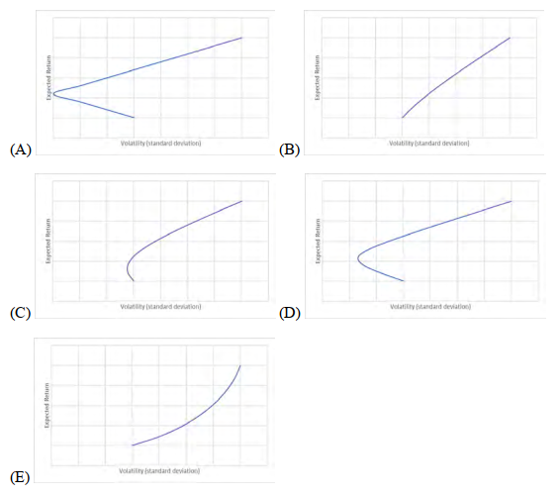

1. *(IFM sample questions)* You are given the following information about the four distinct portfolios:

|  |  |  |
| --- | --- | --- |
| **Portfolio** | **Expected Return** | **Volatility** |
| **P** | 3% | 10% |
| **Q** | 5% | 10% |
| **R** | 5% | 15% |
| **S** | 7% | 20% |

Determine which two of the four given portfolios are NOT efficient.

1. P and Q
2. P and R
3. P and S
4. Q and R
5. Q and S